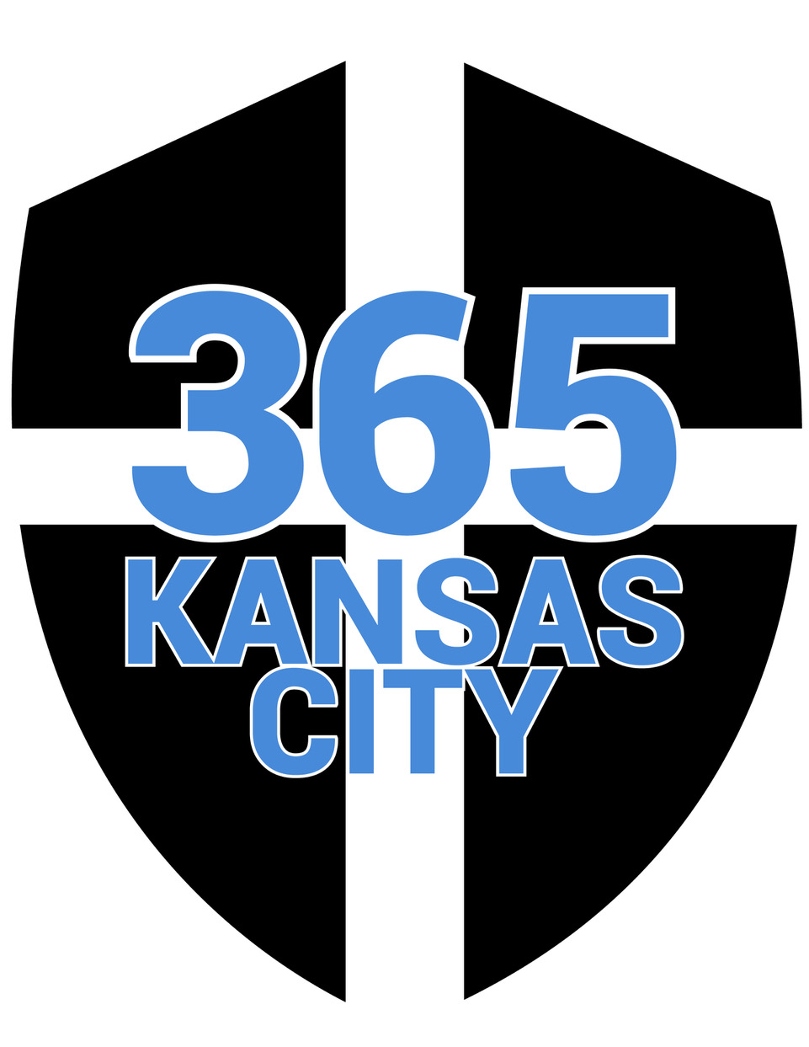
2017 Summer Meet Schedule
- 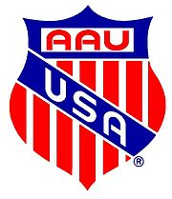 AAU District Qualifier: BG Stadium - El Dorado, Kansas June 3rd
- AAU District Qualifier: William Chrisman H.S. - Independence, Missouri June 10th
- AAU Regional Qualifier: Missouri Southern State University - Joplin, Missouri June 22 – 25
- DEAD WEEK: June 26-July 2 (no practices, athletes will do recovery runs on their own)
- 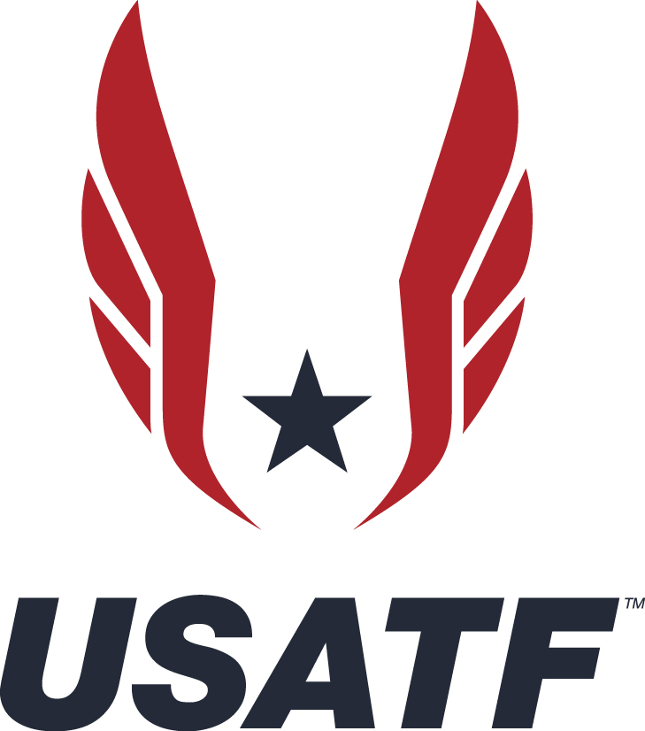USATF Regionals: Missouri Southern State University - Joplin, Missouri July 6-9 (On your own)
- Sunflower State Games: Topeka, Kansas July 15th
- USATF Nationals: University of Kansas - Lawrence, Kansas July 24 - 30 (Coach Jack and Coach Sarah)
- AAU Nationals: Eastern Michigan University - Detroit, Michigan July 28 - August 5

FUELED BY GRACE. POWERED BY GOD.

